

**Capstone Project Report**

**Report 6 – Software User Guides**

– HoChiMinh, April 2025 –

**Table of Contents**

I. Record of Changes. 3

II. Release Package & User Guides. 4

1. Deliverable Package. 4

2. Installation Guides. 4

2.1 System Requirements. 4

2.2 Installation Instruction. 4

3. User Manual 4

3.1 Overview.. 4

3.2 Workflow 1. 4

3.3 Workflow 2. 4

# I. Record of Changes

|  |  |  |  |
| --- | --- | --- | --- |
| Date | A*  M, D | In charge | Change Description |
|  |  |  |  |
|  |  |  |  |
|  |  |  |  |
|  |  |  |  |
|  |  |  |  |
|  |  |  |  |
|  |  |  |  |
|  |  |  |  |
|  |  |  |  |
|  |  |  |  |
|  |  |  |  |
|  |  |  |  |
|  |  |  |  |

*A - Added M - Modified D - Deleted

# II. Release Package & User Guides

## 1. Deliverable Package

|  |  |  |
| --- | --- | --- |
| **No.** | **Deliverable Item** | **Description** |
| 1 | Schedule/Task Tracking | Modify |
| 2 | Project Backlog | Modify |
| 3 | Source Codes | Modify |
| 4 | Database Script(s) | Modify |
| 5 | Final Report Document | New |
| 6 | Test Cases Document | New |
| 7 | Defects List | New |
| 8 | Issues List | New |
| 9 | Slide | Modify |

## 2. Installation Guides

### 2.1 System Requirements

**Client Applications**

**Mobile application** (React Native)

**Web application** (Next.js)

**Server:** VPS running Ubuntu Server

**Database:**MongoDB

**File Storage:**Firebase (Google Firebase)

**Operating Systems:** MacOS, Microsoft Windows.

**Frameworks & Versions:**Node.js: v20.1.1,Next.js: 15.1.1,React Native: 0.76.7,NestJS: Latest version compatible with Node.js 20+

### 2.2 Installation Instructions

Visual Studio Code

Download and install from: <https://code.visualstudio.com/download>

Android Studio (for React Native development)

Download and install from: <https://developer.android.com/studio>

Nodejs

Download and install Node.js v20.1.1 from: <https://nodejs.org/en/download>

**project installation:**[Vin Shuttle](https://github.com/BenSkye/Vin_Shuttle_Capstone)

Backend installation:

Step 1: Download code package in GitHub via link

Step 2: open project with terminal (macOS) or cmd (Win10)

● Redirect to the path of the project (using cd *path)

● Run an app in Visual Studio ( recommended) (using code .)

Step 3: Open terminal in Visual Studio and Install all modules with command line “npm install”.

Step 4: Run “npm run start” to start the project.

Frontend installation:

Step 1: Download code package in GitHub via link

Step 2: open project with terminal (macOS) or cmd (Win10)

●       Redirect to the path of the project (using cd *path)

●       Run an app in Visual Studio ( *recommended*) (using code .)

Step 3: Open terminal in Visual Studio and Install all modules with command line

*cd frontend-customer or cd frontend-admin*

*“****npm install****”.*

Step 4: Run *“****npm run dev****”* to start the project.

## 3. User Manual

### 3.1 Overview

Workflow 1: Booking by hours

Workflow 2: Booking by scenic route

Workflow 3: Booking by destination

Workflow 4: Booking share

### 3.2 Workflow 1: Booking by hours

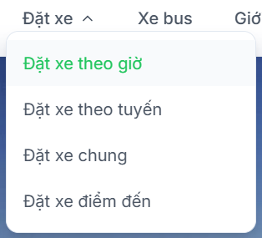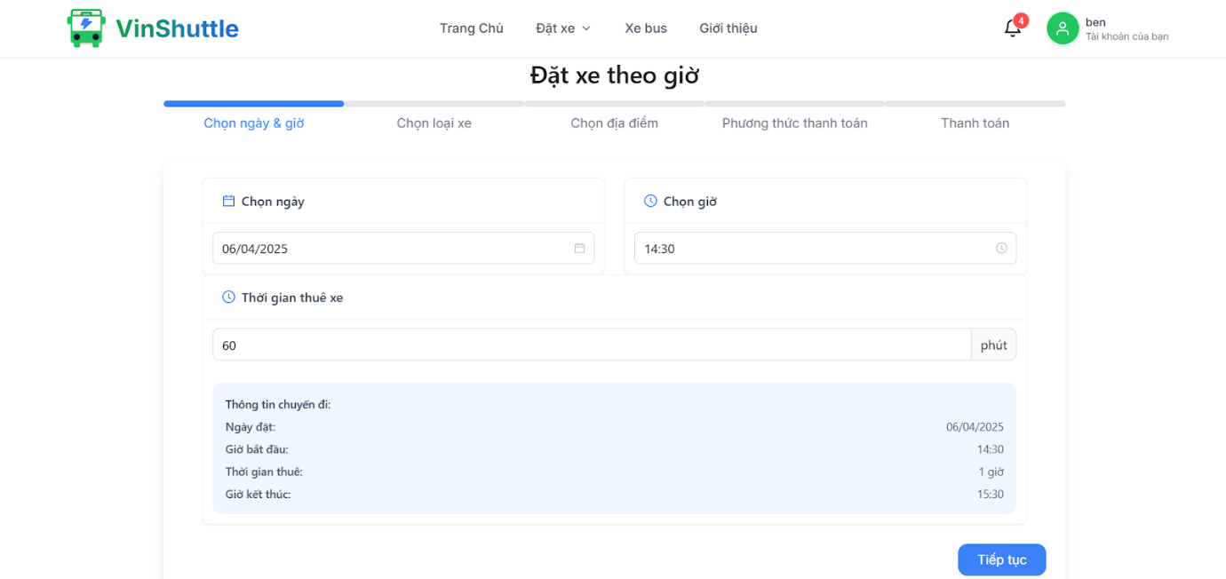

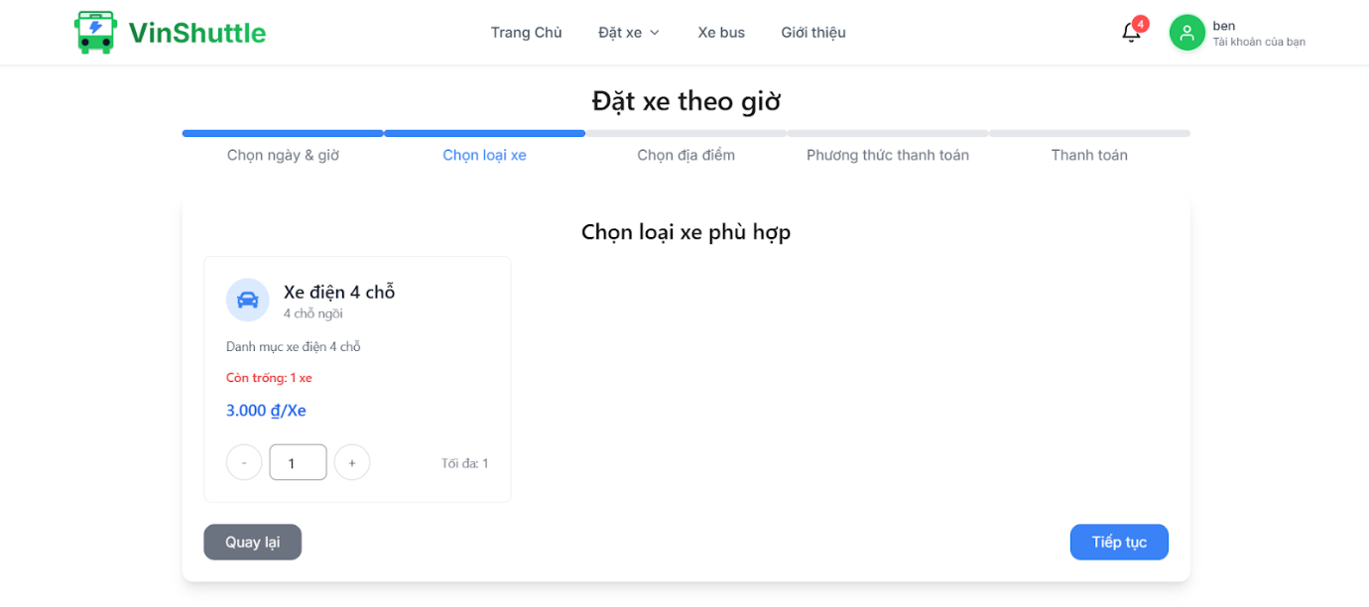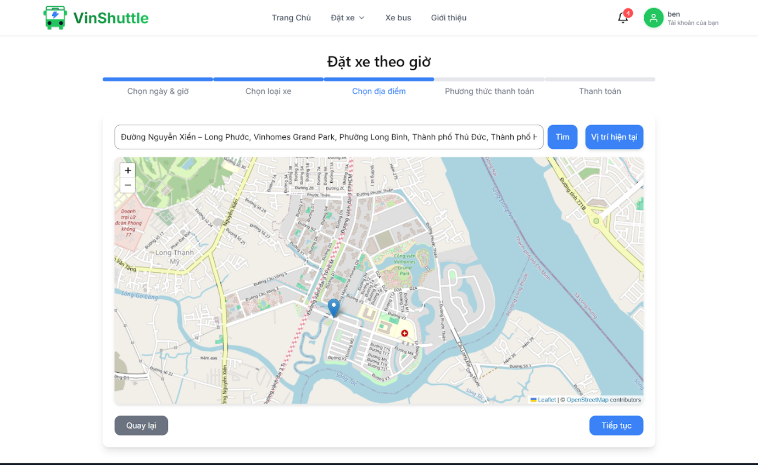

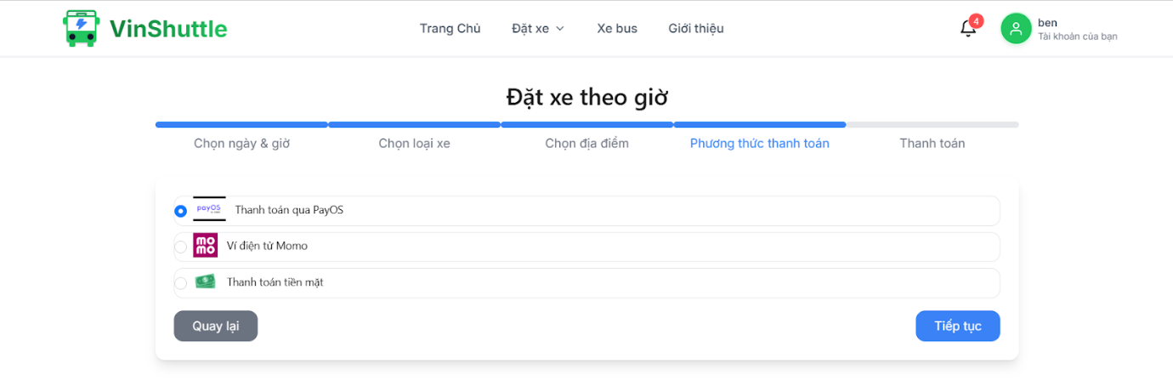

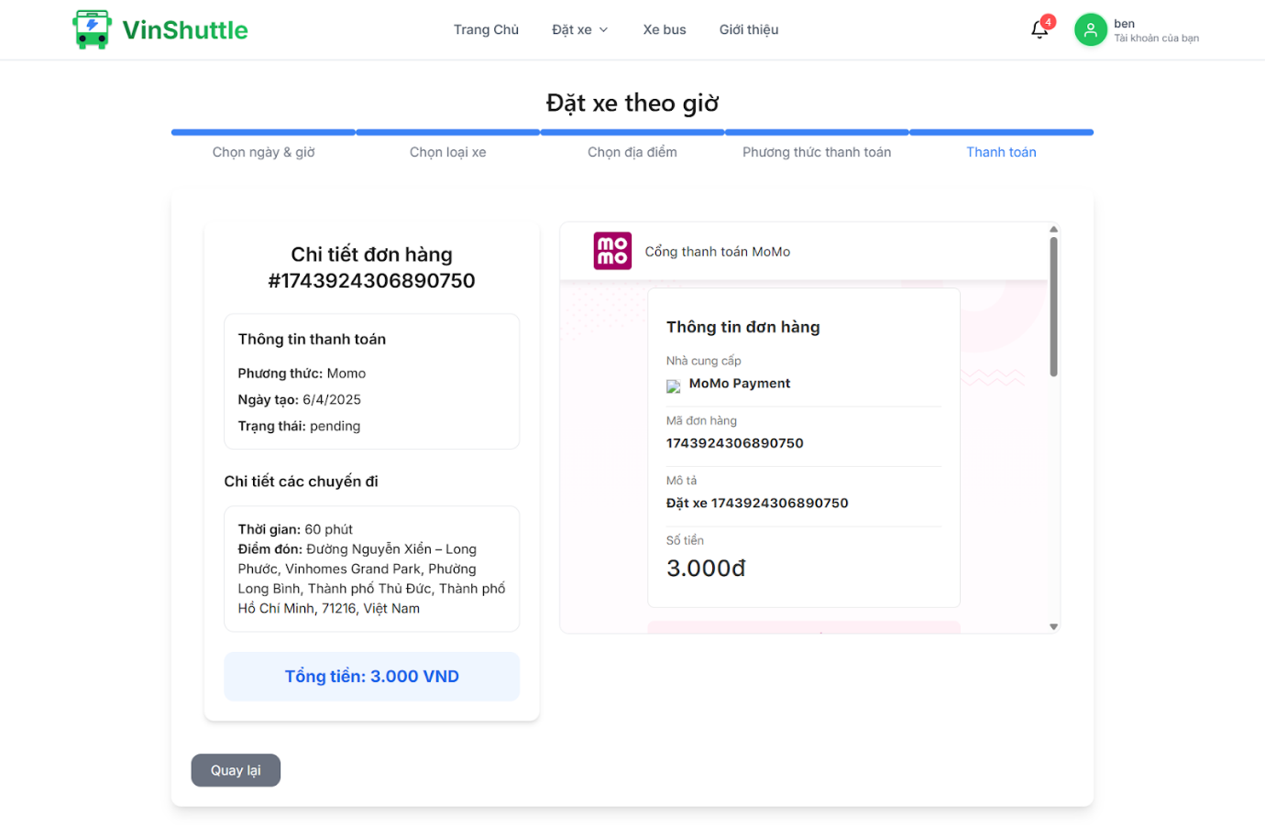

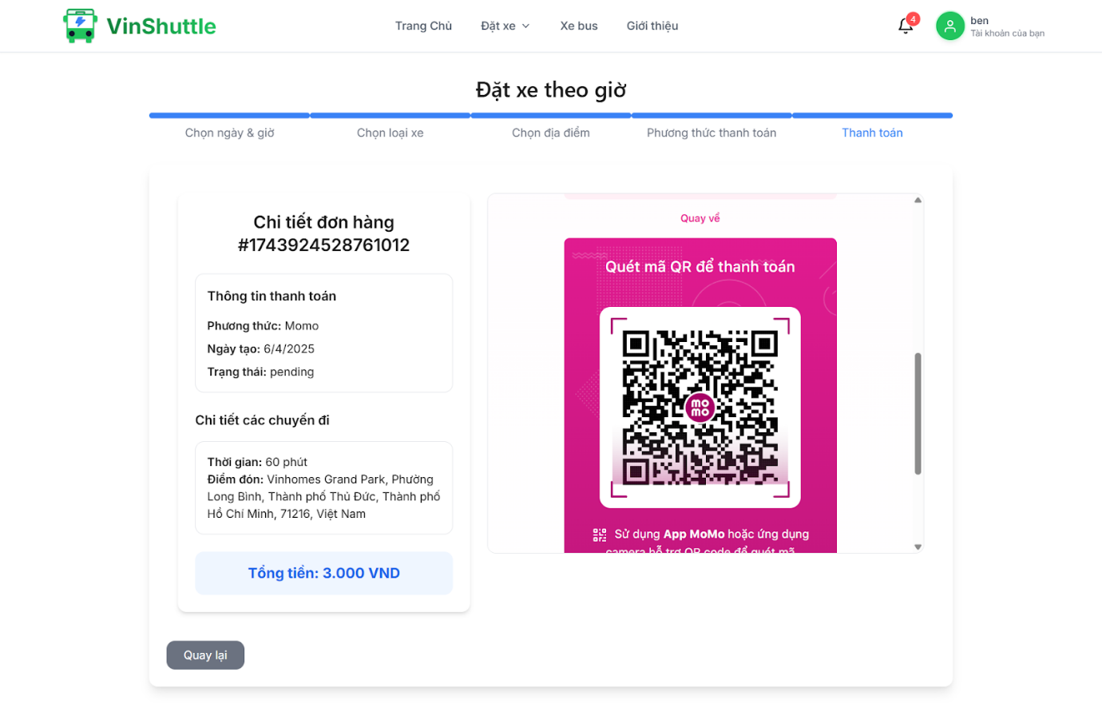

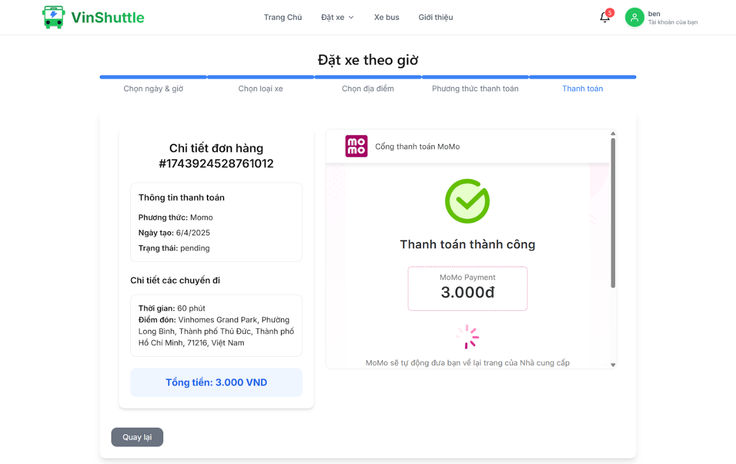

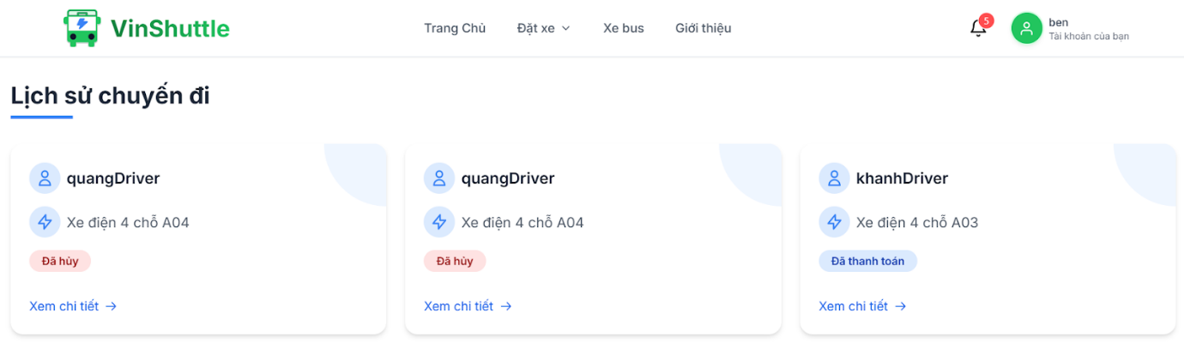

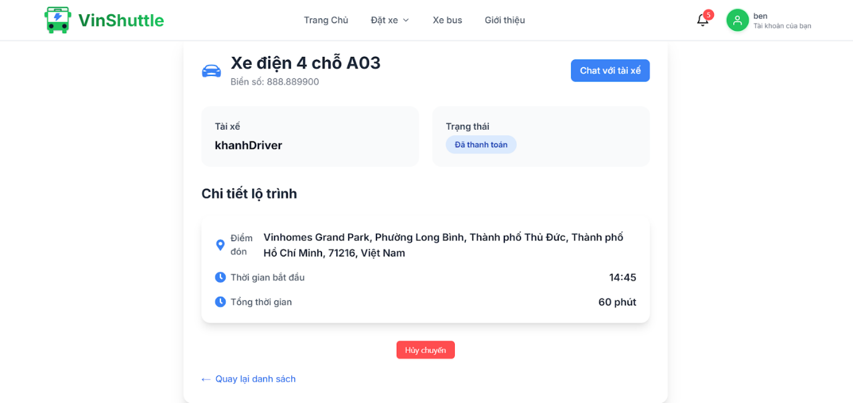

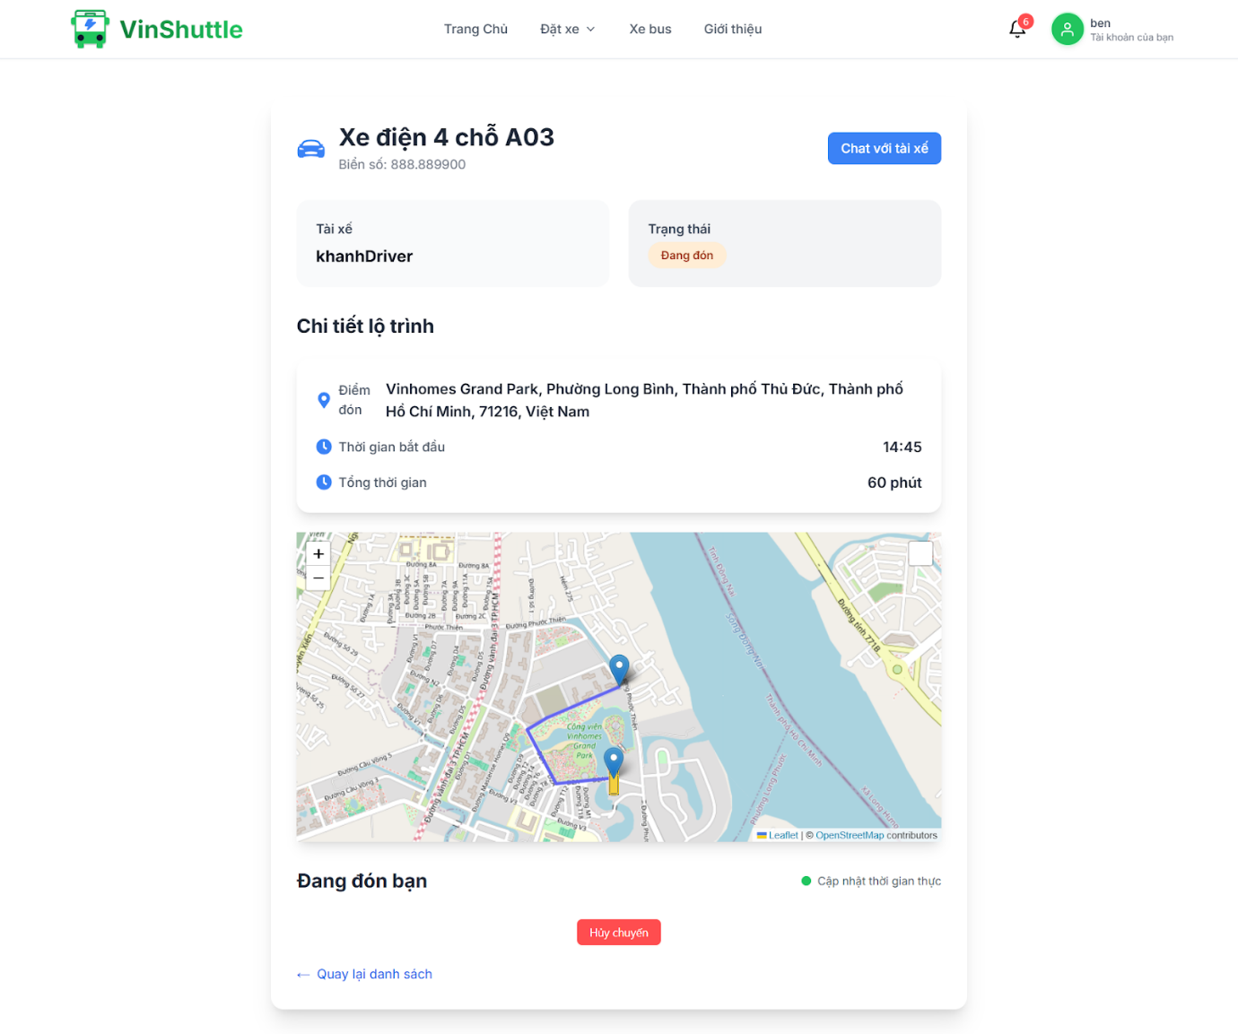

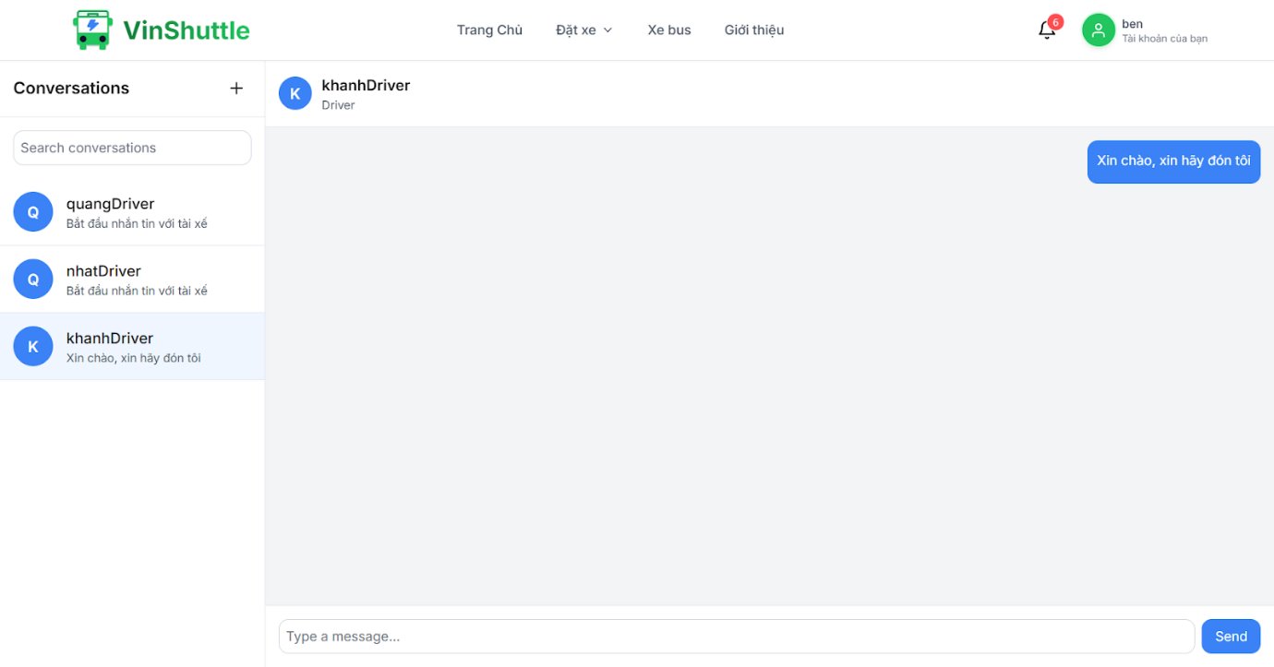

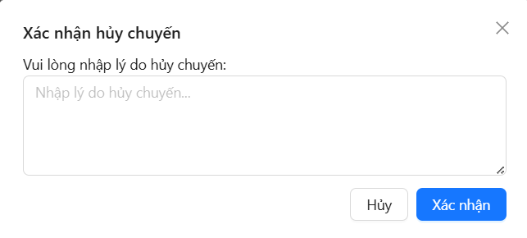

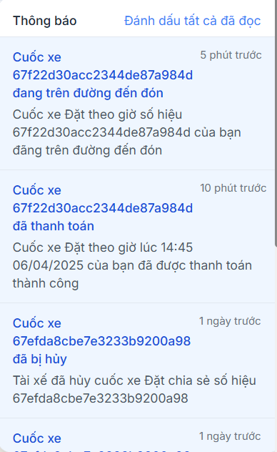

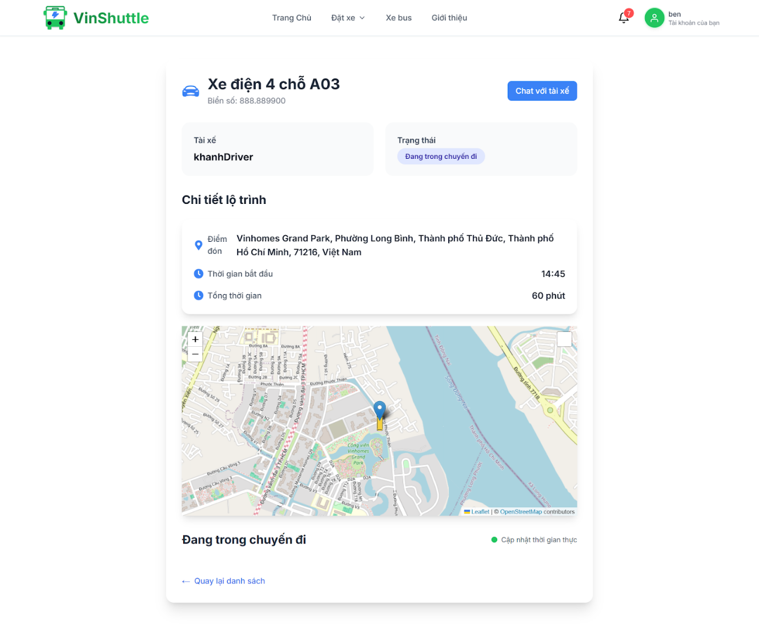

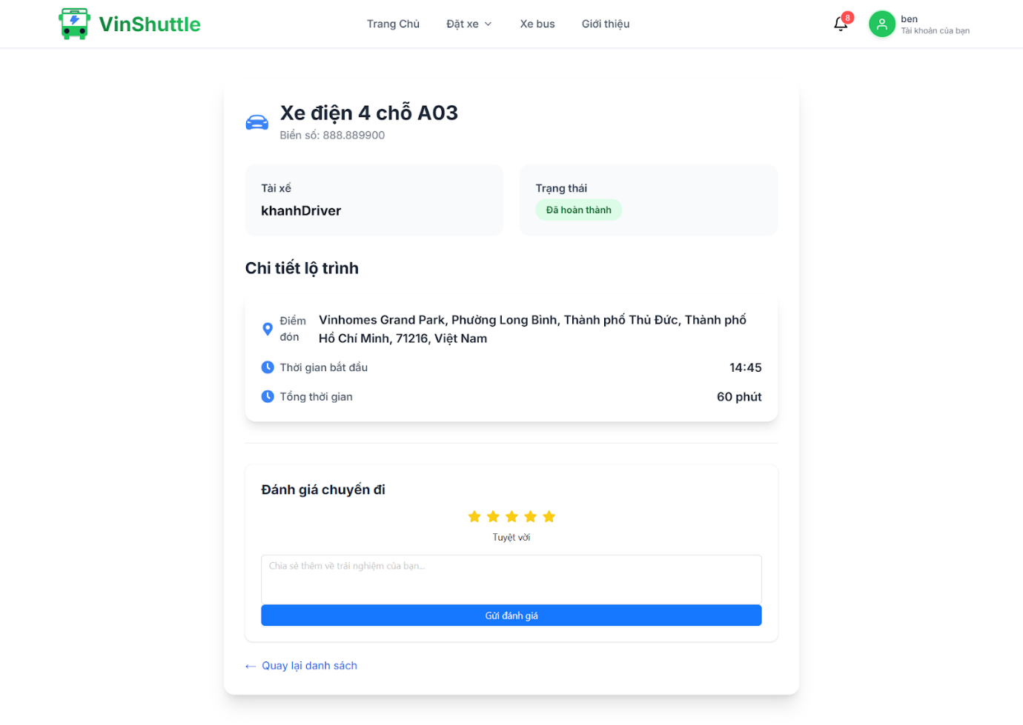

### 3.3 Workflow 2: Booking by scenic route

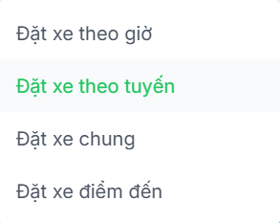

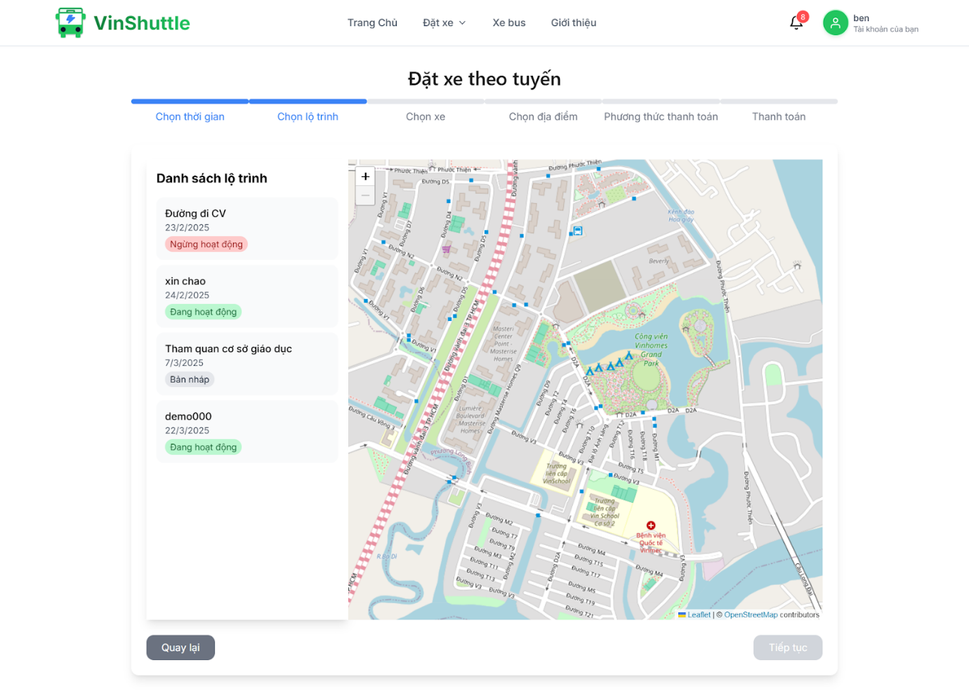

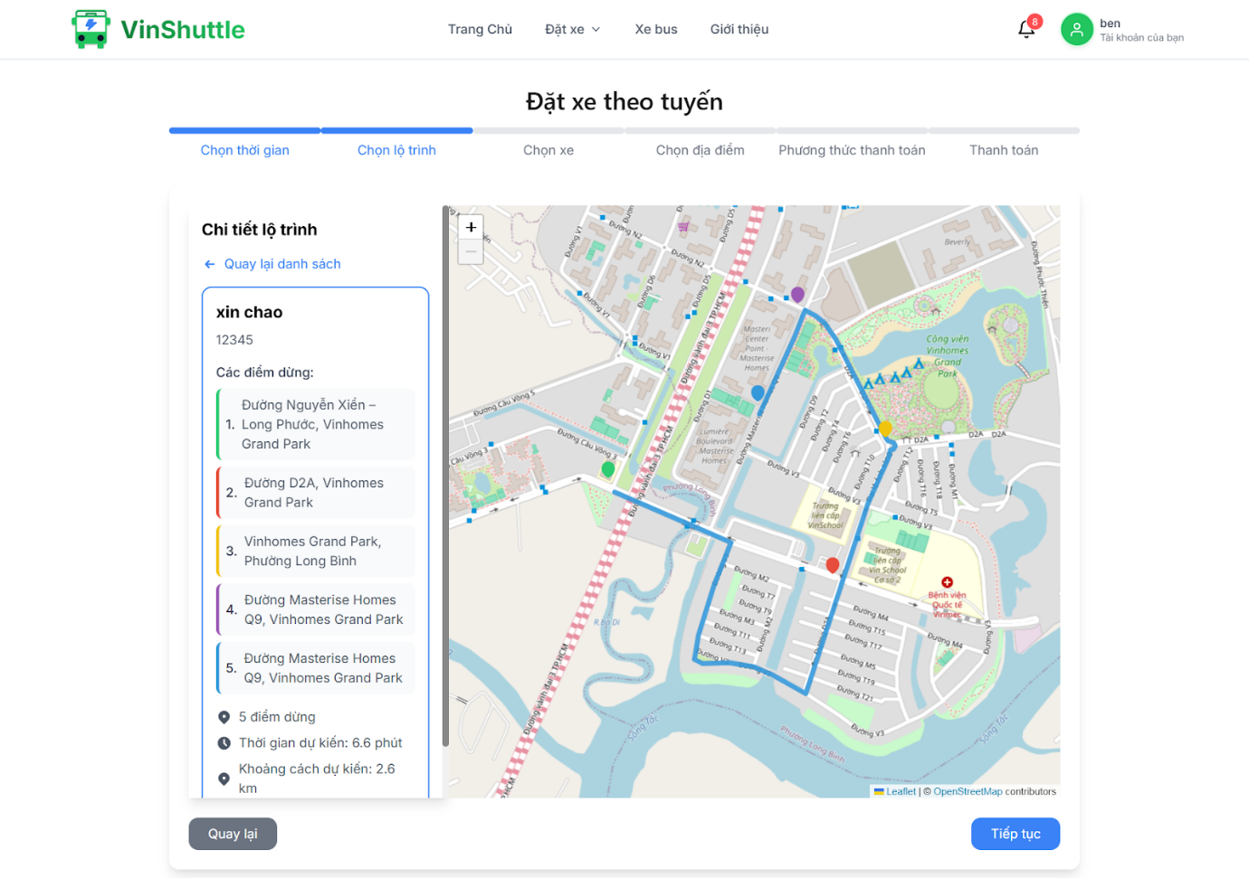

### 3.4 Workflow 3: Booking by destination

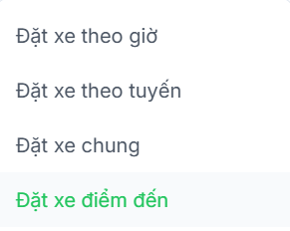

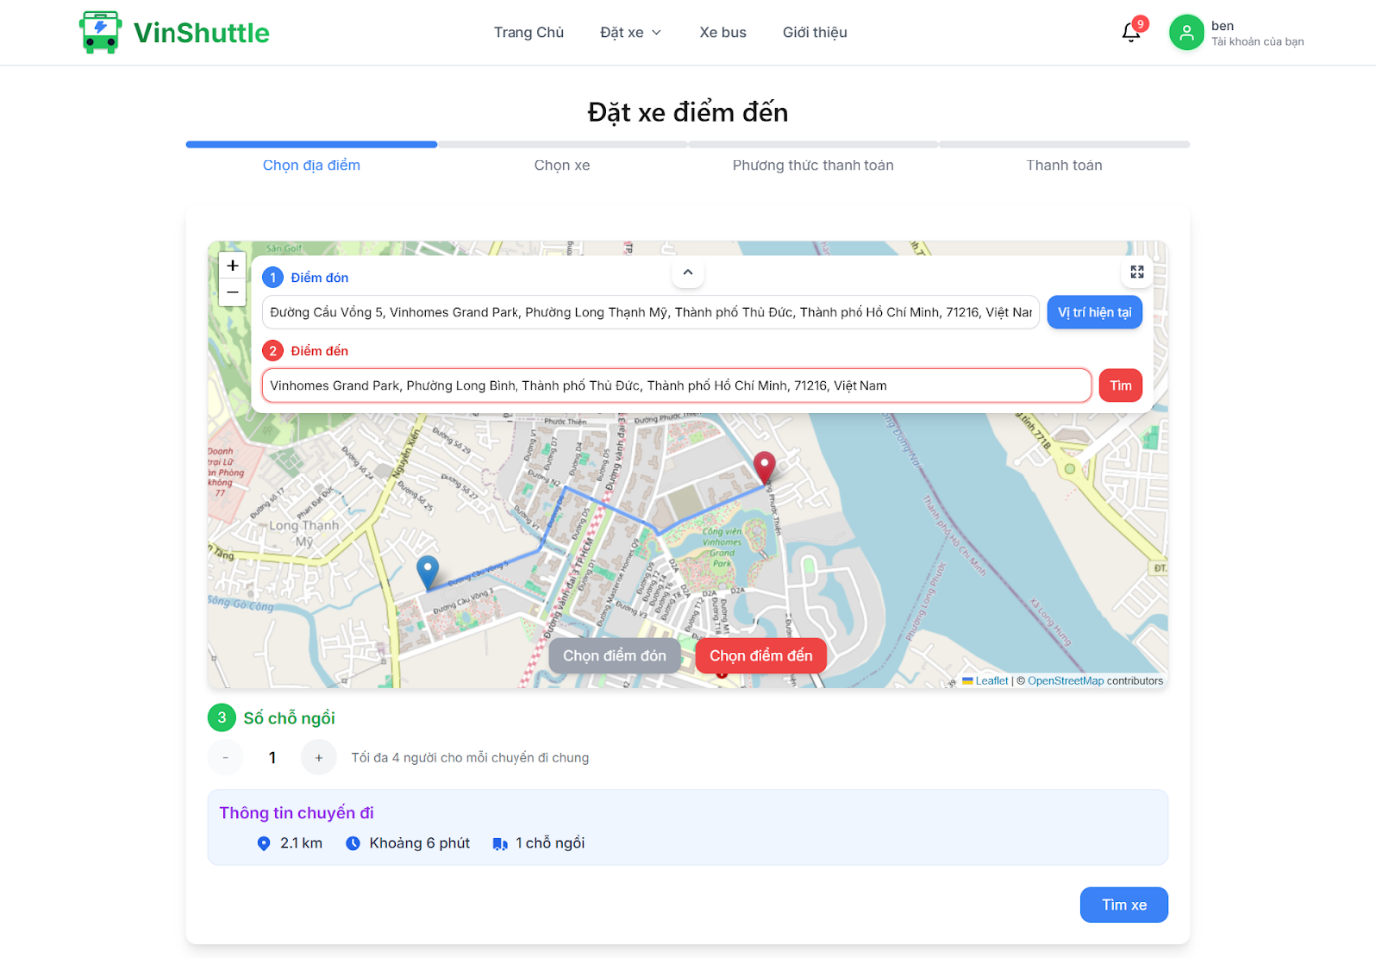

### 3.5 Workflow 4: Booking share

